Lab 10 – Metasploit

* 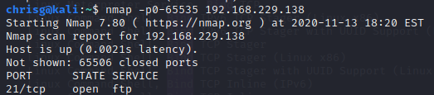Show a screenshot showing how you found a vulnerability. (2 points)

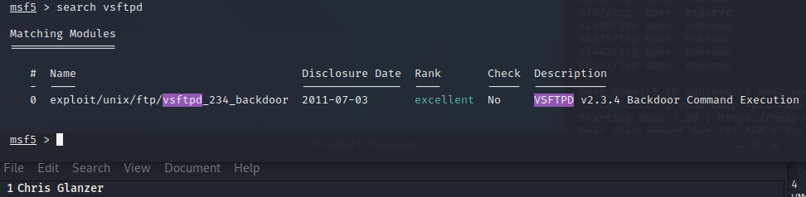SNIP

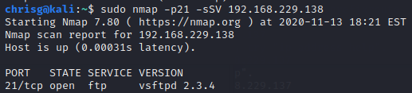

* Show a screenshot setting a payload. (2 points)

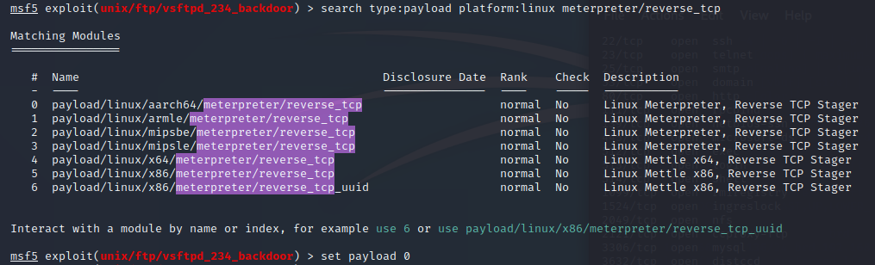

* 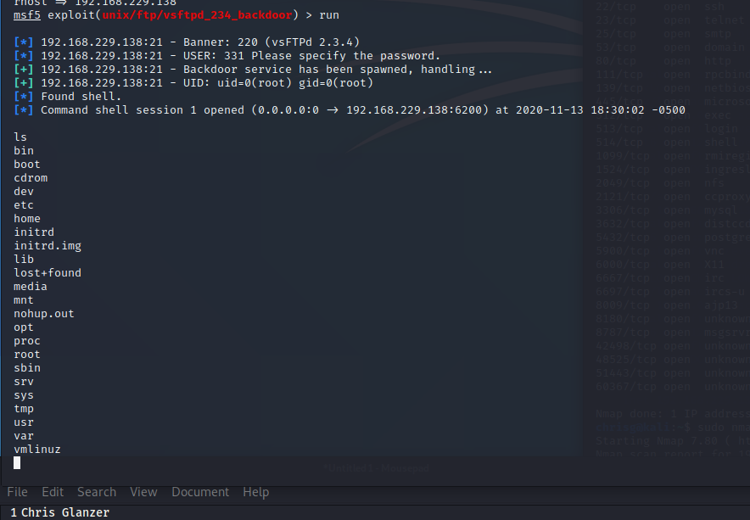Show a screenshot showing successful compromise. (2 points)
* Show a screenshot showing a Meterpreter shell. (2 points)
  + 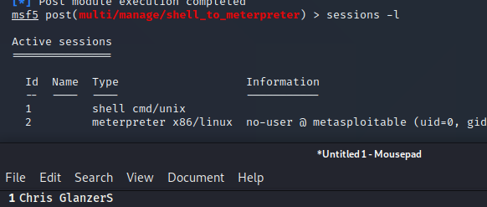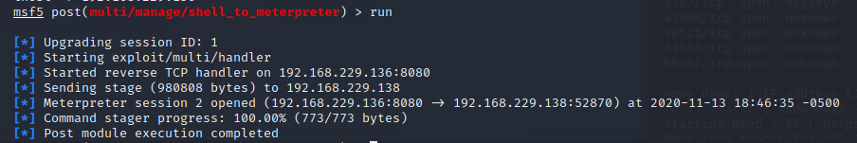Depending on what you do, you may need to upgrade to a meterpreter shell. If so, **shell_to_meterpreter** might be useful.
* Show a screenshot showing you downloading files from the target. (2 points) 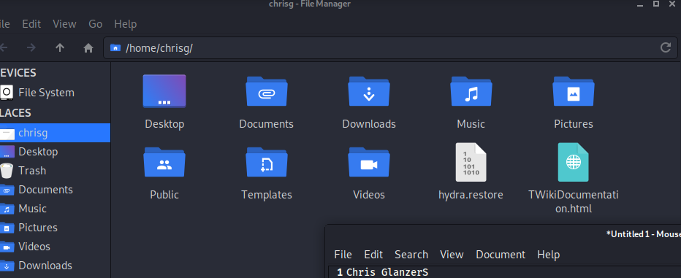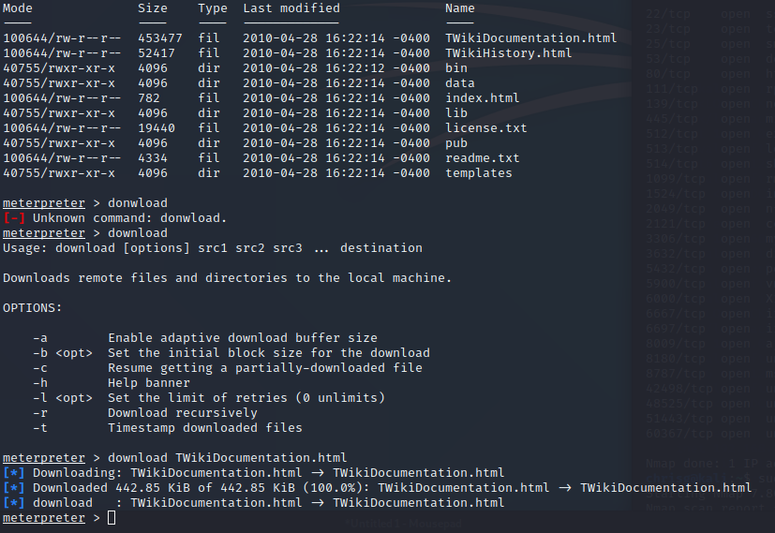

**Please include your name visible in a couple of the screenshots. One thing that works well is just have your name in a file and behind terminal, which is semi-transparent.**

**Deliverables**

* These MUST be contained all in one PDF or DOC/DOCX.
* Crop screenshots appropriately; points are taken off if this is not done.